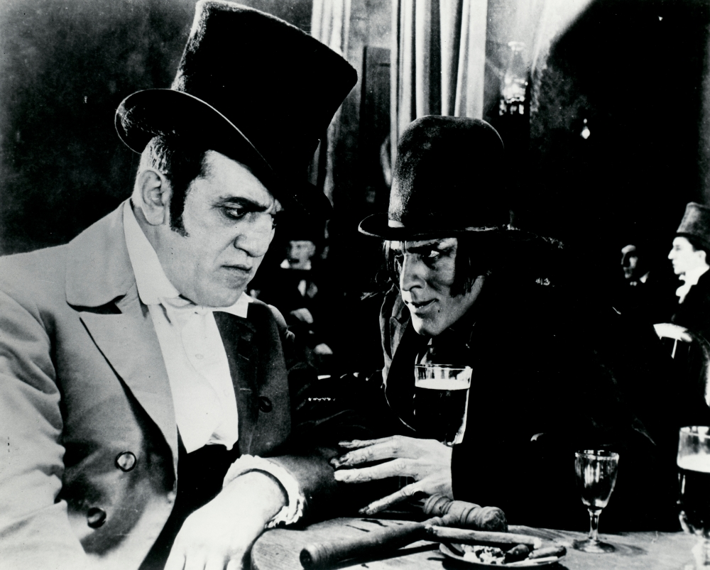

The Strange Case of Dr Jekyll and Mr Hyde: GCSE Revision Guide
Get yourself ultra-ready for your AQA English Literature Paper 1 Section B exam question with this comprehensive revision pack!

The Strange Case of Dr Jekyll and Mr Hyde by Robert Louis Stevenson begins not from Dr Jekyll’s perspective but that of Mr Utterson, a typical Victorian gentleman in terms of manners and behaviour.
A quick plot summary:
- Utterson finds out about the young girl and the evil man who apparently trampled over her. He also finds out this man is known to his friend, Dr Jekyll.
- Utterson is intrigued by Hyde and goes to find him. Meeting him, he is puzzled why a respectable man like Jekyll would want anything to do with him.
- After a year, the respected gentleman Sir Danvers Carew is killed by Hyde. Dr Jekyll will not speak to anyone – at the same time, Mr Hyde disappears.
- Utterson is concerned about his friend and goes to speak to Dr Lanyon about Hyde. Like Jekyll, Lanyon will not speak to him about it. However, he does give Utterson a letter that he says must not be read until Jekyll either disappears or dies.
- Utterson is called to Jekyll’s house in the middle of the night. In the laboratory lies a dead person. Utterson reads Jekyll’s new will and takes Jekyll’s confession back to his house to read.
- Now that Jekyll has disappeared, Utterson reads Lanyon’s letter. It discusses Jekyll’s experiments.
- Jekyll’s confession finally reveals to the reader and Utterson that Jekyll is Hyde and vice versa.
The plot in more detail:
- Utterson and Enfield are taking a walk, during which they find a bizarre and very mysterious looking building. This building is attached to Dr Jekyll’s house – who is a friend of Utterson’s.
- The building reminds Enfield of the person who lives there, a Mr Hyde, and recalls an incident where Hyde trampled over a young girl without feeling any apparent guilt.
- Utterson is intrigued by Hyde and wants to find out more about him, and so he begins to gather information and see if he can meet him.
- Utterson meets Hyde and is genuinely shocked by his appearance. When he speaks to Hyde, Hyde is blunt and violent and Utterson begins to worry for his friend Dr Jekyll. Utterson heads to Dr Jekyll’s house to warn him, but Poole – Jekyll’s servant – says his master is not there. Additionally, Poole reveals that Jekyll has told all the staff to let Mr Hyde go in and out of the house whenever he likes.
- After two weeks, Utterson speaks to Jekyll at a mutual friend’s dinner party. As a lawyer, Utterson has seen Jekyll’s latest will, which names Hyde as the man to inherit his fortune. Jekyll tells Utterson not to worry and requests that he does not speak of Hyde anymore as he has everything firmly under control.
- After a year, Sir Danvers Carew – a very well respected individual – is murdered by Hyde. The murder weapon is Dr Jekyll’s walking cane, linking Utterson’s friend to the crime. A maid, who witnessed the attack, is distraught at the sheer violence she saw. Utterson is now motivated to solve this mystery and help his friend.
- After the murder, Jekyll no longer sees his friends and becomes increasingly isolated. Jekyll tells everyone that he no longer has any links to Hyde. The police investigating Carew’s murder say Hyde has disappeared. When Jekyll hears of this, he seems to become happier and more social with his friends.
- Out of nowhere, Jekyll once more becomes isolated and will not speak to Utterson. Utterson goes to Dr Lanyon, who is one of Jekyll’s oldest friends. Lanyon is very ill and will soon die – but refuses to speak about Jekyll. He leaves a letter for Utterson to read once Jekyll has either disappeared or died – further adding to the mystery of the novella.
- Poole arrives at Utterson’s house and requests that he go with him to Jekyll’s home. Outside of Jekyll’s laboratory (the door is locked), he can hear strange noises coming from inside. Poole reveals that the door has been locked for several days. Whoever is inside keeps asking for different chemicals. This person has complained to Poole that the chemicals provided to him contain impurities.
- Frustrated and deeply concerned, Utterson and Poole break down the door to the laboratory. Lying on the floor is a very small, deformed individual who is dressed in Jekyll’s clothes. On the desk is a new will with Utterson named as the new inheritor of Jekyll’s fortune, not Hyde. Jekyll has also left a confession. Utterson returns home to read all the documents.
- Now that Jekyll has disappeared, Utterson reads Dr Lanyon’s letter which reveals the experiments Jekyll was carrying out. Jekyll’s confession explains his thoughts during the experiments and that Jekyll is Hyde. Utterson cannot believe what he has read.

Revision Activity 1: Plot analysis
Challenge: Re-read the plot summaries and highlight key information. Without looking at your notes, write down your own summary of the plot.
Extra Challenge: Why does Stephenson choose to begin the novel with Utterson? Why does it finish with the perspectives of Lanyon and Jekyll?
Mega Challenge: Look at the way Stephenson orders his ideas. How does this structure help to build up a sense of mystery for the reader?
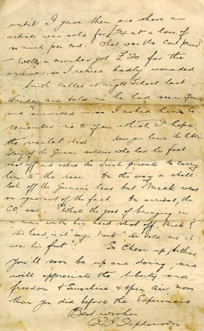
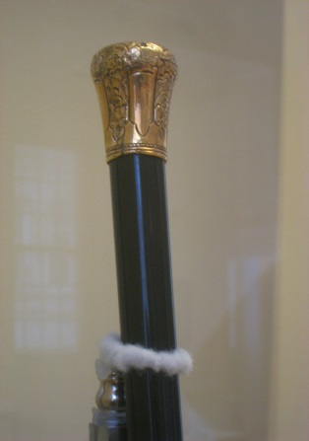
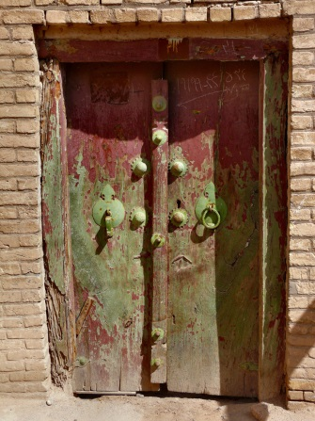
Revision Activity 2: Key symbols
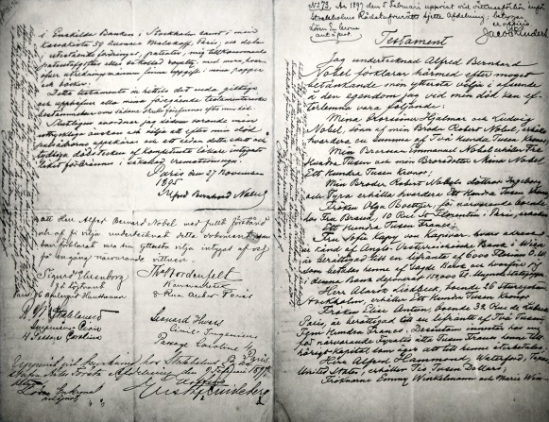
Here are four key symbols within the novella.
What does each of them represent?

- The Door: ______________________________________________________________________________________________________________________________________________________
- The Will/Confession: ______________________________________________________________________________________________________________________________________________________
- The Walking Cane: ______________________________________________________________________________________________________________________________________________________
- The Letter: ______________________________________________________________________________________________________________________________________________________

Extra Challenge: Using quotes from the text in your notes, explain what each symbol represents in the novel and the impact it has on the reader.
Mega Challenge: Make notes on how each key symbol links to each key theme. Include quotes within your notes as well as ideas on the effects on the reader of each symbol.

Revision Activity 3: Key quotes
Below are many quotes from throughout the text organised by theme. Read through them and choose three quotes from each theme.
Challenge: Learn those quotes off by heart and write each of them out several times to help you remember them.
Extra Challenge: Use these quotes to make notes on each of the characters (Utterson, Enfield, Jekyll, Hyde, Lanyon). What kind of characters are they?
Mega Challenge: Do particular characters represent particular themes? Use the quotes from within this pack to make notes on this.
Good v Evil
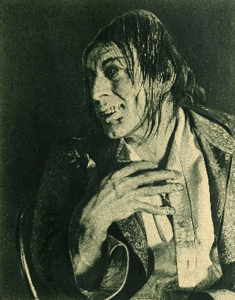
“In this character, it was frequently his fortune to be the last reputable acquaintance and the last good influence in the lives of downgoing men.”(Chapter 1)
Mr Utterson wants to help those who wrong rather than judge them .

“For my man was a fellow that nobody could have to do with, a really damnable man; and the person that drew the cheque is the very pink of the proprieties, celebrated too, and (what makes it worse) one of your fellows who do what they call good.” (Chapter 1)
Enfield explains to Utterson that Mr Hyde and Dr Jekyll are complete opposites or the ‘antithesis’ of each other.

“This document had long been the lawyer's eyesore.” (Chapter 2)
Utterson hates the will that has been given to him by Dr Jekyll because it names Mr Hyde as the man who will inherit his fortune. Utterson knows Hyde is evil – so why is Jekyll giving this man all his money?

“And the lawyer set out homeward with a very heavy heart. "Poor Harry Jekyll," he thought, "my mind misgives me he is in deep waters! He was wild when he was young; a long while ago to be sure; but in the law of God, there is no statute of limitations.”
"This Master Hyde, if he were studied," thought he, "must have secrets of his own; black secrets, by the look of him; secrets compared to which poor Jekyll's worst would be like sunshine." (Chapter 2)
Utterson believes Dr Jekyll must have some dark secrets from his past that Mr Hyde is using against him to blackmail him.

“And as she so sat she became aware of an aged beautiful gentleman with white hair, drawing near along the lane; and advancing to meet him, another and very small gentleman, to whom at first she paid less attention.” (Chapter 4)
The maid who witnesses the attack by Mr Hyde on Sir Danvers Carew, describes Carew as ‘beautiful’ but initially ignores Hyde. The characters meeting here is a representation of good v evil.

“And next moment, with ape-like fury, he was trampling his victim under foot and hailing down a storm of blows, under which the bones were audibly shattered and the body jumped upon the roadway. At the horror of these sights and sounds, the maid fainted.” (Chapter 4)
The narrator describes the attack that the maid witnessed. This emphasises just how evil Hyde is.

“Think before you answer, for it shall be done as you decide. As you decide, you shall be left as you were before, and neither richer nor wiser, unless the sense of service rendered to a man in mortal distress may be counted as a kind of riches of the soul. Or, if you shall so prefer to choose, a new province of knowledge and new avenues to fame and power shall be laid open to you, here, in this room, upon the instant; and your sight shall be blasted by a prodigy to stagger the unbelief of Satan."
Hyde gives Dr Lanyon a choice: he can witness Hyde’s transformation into Jekyll or he can continue to live in ignorance. (Chapter 9)

“Both sides of me were in dead earnest; I was no more myself when I laid aside restraint and plunged in shame, than when I laboured, in the eye of day, at the futherance of knowledge or the relief of sorrow and suffering.” (Chapter 10)
Jekyll admits that he is made up equally of good and evil.

“If each, I told myself, could be housed in separate identities, life would be relieved of all that was unbearable.” (Chapter 10)
Jekyll explains that if humanity can rid itself of evil then it would make life so much better.

“I knew myself, at the first breath of this new life, to be more wicked, tenfold more wicked, sold a slave to my original evil; and the thought, in that moment, braced and delighted me like wine. I stretched out my hands, exulting in the freshness of these sensations; and in the act, I was suddenly aware that I had lost in stature.” (Chapter 10)
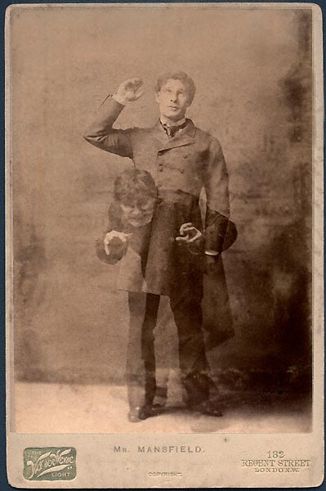
Jekyll describes that being Hyde was enjoyable, that he felt a sense of freedom in no longer embracing his responsi bilities to be moral and good.

“I had now two characters as well as two appearances, one was wholly evil, and the other was still the old Henry Jekyll, that incongruous compound.” (Chapter 10)
Jekyll explains that Hyde was pure evil, but Jekyll was still a mix of both evil and good. He had not been successful in creating a wholly good person.

“I think I was glad to know it; I think I was glad to have my better impulses thus buttressed and guarded by the terrors of the scaffold. Jekyll was now my city of refuge; let but Hyde peep out an instant, and the hands of all men would be raised to take and slay him.” (Chapter 10)
Jekyll feels relieved that Hyde can disappear and ‘hide’ within him after the murder of Sir Danvers Carew, but at the same time he knows everyone will be after Hyde should he reappear again.

“I resolved in my future conduct to redeem the past; and I can say with honesty that my resolve was fruitful of some good.” (Chapter 10)
Jekyll explains that he tried to make up for the crimes of Hyde by doing good to other people.

“I sat in the sun on a bench; the animal within me licking the chops of memory; the spiritual side a little drowsed, promising subsequent penitence, but not yet moved to begin. After all, I reflected, I was like my neighbours; and then I smiled, comparing myself with other men, comparing my active good-will with the lazy cruelty of their neglect. And at the very moment of that vainglorious thought, a qualm came over me, a horrid nausea and the most deadly shuddering. These passed away, and left me faint; and then as in its turn faintness subsided, I began to be aware of a change in the temper of my thoughts, a greater boldness, a contempt of danger, a solution of the bonds of obligation. I looked down; my clothes hung formlessly on my shrunken limbs; the hand that lay on my knee was corded and hairy. I was once more Edward Hyde. A moment before I had been safe of all men's respect, wealthy, beloved—the cloth laying for me in the dining-room at home; and now I was the common quarry of mankind, hunted, houseless, a known murderer, thrall to the gallows.” (Chapter 10)
Jekyll is described as good here and at one with the world around him, but he suddenly transforms into Hyde and we can see how his thoughts begin to chance as well. He becomes instantly evil.

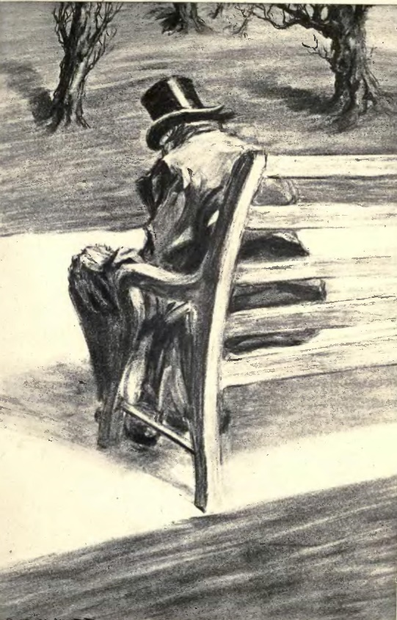
Repression
Repression means to hide and fight against thoughts and actions that you think are wrong or would be viewed as wrong by other people in society. Repression is a key theme in Victorian society where people were judged by their actions very carefully.
Having a ‘reputation’ – good or bad – could change your entire life.

“He was austere with himself; drank gin when he was alone, to mortify a taste for vintages; and though he enjoyed the theatre, had not crossed the doors of one for twenty years. But he had an approved tolerance for others; sometimes wondering, almost with envy, at the high pressure of spirits involved in their misdeeds; and in any extremity inclined to help rather than to reprove. “(Chapter 1)
Utterson is very careful in terms of how he behaves. He only drinks alcohol whe n alone and has not even been to the theatre for twenty years. However, he is happy to be tolerant towards other people and their behaviours, but lots of people were not. Utterson can often be jealous of others for their behaviour.

You start a question, and it's like starting a stone. You sit quietly on the top of a hill; and away the stone goes, starting others; and presently some bland old bird (the last you would have thought of) is knocked on the head in his own back garden and the family have to change their name. No sir, I make it a rule of mine: the more it looks like Queer Street, the less I ask. (Chapter 1)
Enfield stops himself from asking questions when he is suspicious for fear of what he might find out. He represses this desire to be inquisitive.

"I am ashamed of my long tongue. Let us make a bargain never to refer to this again." (Chapter 1)
Enfield says he is ashamed of himself for gossiping. He and Utterson agree not to do it anymore.

“I come here at the instance of your colleague, Dr. Henry Jekyll, on a piece of business of some moment; and I understood ..." He paused and put his hand to his throat, and I could see, in spite of his collected manner, that he was wrestling against the approaches of the hysteria—"I understood, a drawer ..." (Chapter 9)
Utterson is desperate to find out about Dr Jekyll but calmly and politely speaks to Dr Lanyon – he represses his excitement, fear and anxiety.

“Hence it came about that I concealed my pleasures; and that when I reached years of reflection, and began to look round me and take stock of my progress and position in the world, I stood already committed to a profound duplicity of me.” (Chapter 10)
Dr Jekyll explains that he repressed his sinful side in public to give the appearance of being respectable.

“At that time my virtue slumbered; my evil, kept awake by ambition, was alert and swift to seize the occasion; and the thing that was projected was Edward Hyde.” (Chapter 10)
Jekyll explains that the more he tried to repress ‘Hyde’ within him, the more keen he became to come out.
“It was Hyde, after all, and Hyde alone, that was guilty. Jekyll was no worse; he woke again to his good qualities seemingly unimpaired; he would even make haste, where it was possible, to undo the evil done by Hyde. And thus his conscience slumbered.” (Chapter 10)
Jekyll makes himself feel better by repressing his conscience. He tells himself that it was Hyde who committed those crimes, not himself.

“My devil had been long caged, he came out roaring.” (Chapter 10)
By repressing Hyde as long as he can, Jekyll only makes him more desperate to ‘come out’.

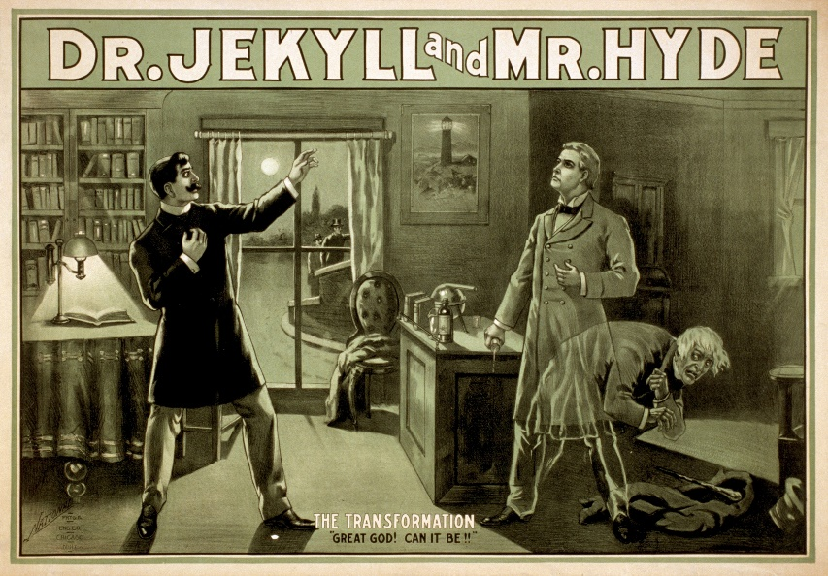
Friendship
“In this character, it was frequently his fortune to be the last reputable acquaintance and the last good influence in the lives of downgoing men.” (Chapter 1)
Utterson is described as a friend to even the most troubled of people. He is, after all, the one that investigates Dr Jekyll because he is so concerned about him and his relationship with Mr Hyde.

"We told the man we could and would make such a scandal out of this as should make his name stink from one end of London to the other. If he had any friends or any credit, we undertook that he should lose them." (Chapter 1)
Utterson threatens Hyde with a loss of reputation, including losing any friends he might have.

“At sight of Mr. Utterson, he sprang up from his chair and welcomed him with both hands.” (Chapter 2)
Dr Lanyon and Utterson have a good friendship and they trust each other. This is important in terms of Utterson unveiling the truth about Jekyll and Hyde.

"But it is more than ten years since Henry Jekyll became too fanciful for me. He began to go wrong, wrong in mind; and though of course I continue to take an interest in him for old sake's sake, as they say, I see and I have seen devilish little of the man.” (Chapter 2)
Dr Lanyon explains that his friendship with Dr Jekyll worsened because of Jekyll’s scientific interests.

“Or else he would see a room in a rich house, where his friend lay asleep, dreaming and smiling at his dreams; and then the door of that room would be opened, the curtains of the bed plucked apart, the sleeper recalled, and lo! there would stand by his side a figure to whom power was given, and even at that dead hour, he must rise and do its bidding.” (Chapter 2)
Utterson dreams of Jekyll somehow being controlled by Hyde. Utterson sides with Jekyll because he is his friend and is therefore instantly biased towards him.

“You could see by his looks that he cherished for Mr. Utterson a sincere and warm affection.” (Chapter 3)
It is clear here that Dr Jekyll sees Utterson as a close friend and enjoys his friendship.

"You know I never approved of it," pursued Utterson, ruthlessly disregarding the fresh topic.
"My will? Yes, certainly, I know that," said the doctor, a trifle sharply. "You have told me so." (Chapter 3)
Utterson believes he is acting in the best interests of his friend Dr Jekyll, and so it quite blunt and honest with him about the will.

"Jekyll," said Utterson, "you know me: I am a man to be trusted. Make a clean breast of this in confidence; and I make no doubt I can get you out of it."
“I will tell you one thing: the moment I choose, I can be rid of Mr. Hyde.”(Chapter 3)
Utterson asks Jekyll to reveal his secret to him in confidence, but Jekyll refuses saying he can get rid of Hyde whenever he wants.

“Mr. Hyde had numbered few familiars—even the master of the servant maid had only seen him twice; his family could nowhere be traced; he had never been photographed; and the few who could describe him differed widely, as common observers will.” (Chapter 4)
Hyde has no friends because he is so evil, therefore few people know what he looks like.

"I have buried one friend to-day," he thought: "what if this should cost me another?" And then he condemned the fear as a disloyalty, and broke the seal.” (Chapter 6)
Even though Utterson is worried that Dr Lanyon’s letter will lead to his friend Dr Jekyll becoming tangled up in the crimes of Mr Hyde, he still decides to open it. Some things are more important than friendship.
“Utterson became so used to the unvarying character of these reports, that he fell off little by little in the frequency of his visits.” (Chapter 6)
Hearing about Dr Jekyll’s changing behaviour, Utterson begins to visit him less frequently and begins to suspect his friend’s character.

The lawyer put it in his pocket. "I would say nothing of this paper. If your master has fled or is dead, we may at least save his credit." (Chapter 8)
Utterson tells Poole the servant that he must not mention Jekyll’s confession to anyone else. Utterson is desperate to protect his friend’s reputation.

“Sir," said I, affecting a coolness that I was far from truly possessing, "you speak enigmas, and you will perhaps not wonder that I hear you with no very strong impression of belief. But I have gone too far in the way of inexplicable services to pause before I see the end." (Chapter 9)
Dr Lanyon agrees to help Jekyll despite Jekyll refusing to tell him his secrets.

“To cast it in with Hyde, was to die to a thousand interests and aspirations, and to become, at a blow and forever, despised and friendless.” (Chapter 10)
In his confession, Jekyll admits that if he becomes Hyde permanently then he will live a life without friends.

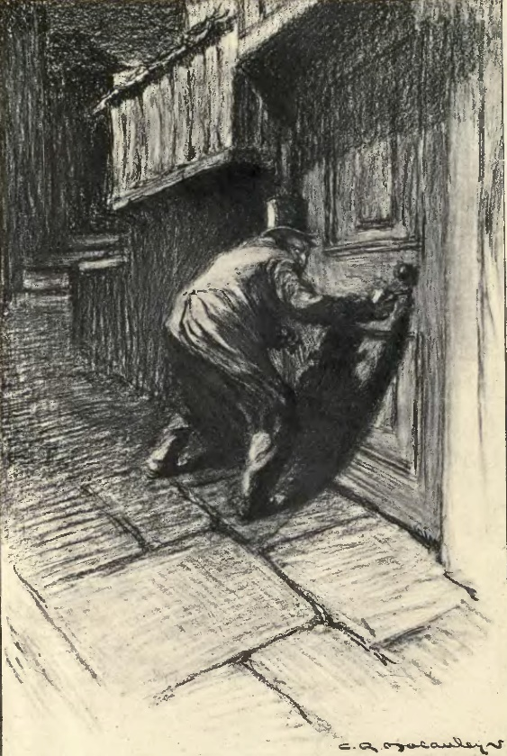
Science and Nature
“Yet his attention had never before been so sharply and decisively arrested; and it was with a strong, superstitious prevision of success that he withdrew i nto the entry of the court.” (Chapter 2)
The very unnatural appearance and behaviour of Mr Hyde makes the very scientific Mr Utterson become very suspicious.

"I never saw a man so distressed as you were by my will; unless it were that hide-bound pedant, Lanyon, at what he called my scientific heresies.” (Chapter 3)
Jekyll is disappointed that Lanyon takes a religious approach to his scientific studies, referring to them as ‘heresies’.

“Only on one point were they agreed; and that was the haunting sense of unexpressed deformity with which the fugitive impressed his beholders.” (Chapter 4)
Hyde’s unnatural appearance makes everyone suspicious of him instantly.

"O God!" I screamed, and "O God!" again and again; for there before my eyes—pale and shaken, and half fainting, and groping before him with his hands, like a man restored from death—there stood Henry Jekyll!” (Chapter 9)
Lanyon describes Hyde’s transformation into Jekyll as ‘like a man restored from death’ – it is unnatural.

“But the temptation of a discovery so singular and profound at last overcame the suggestions of alarm.” (Chapter 10)
Jekyll knew he was taking a risk experimenting on himself, but his desire for discovery overtook any of his worries.

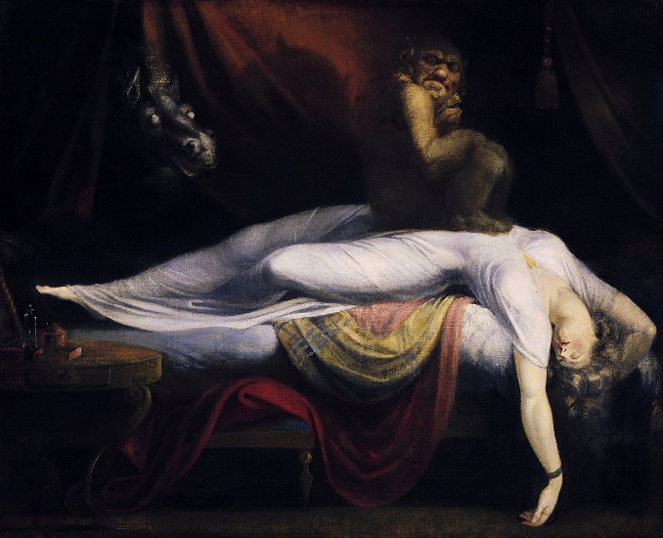
Religion
When Robert Louis Stephenson wrote Jekyll and Hyde, Britain was still very much a Christian country and most people held strong religious beliefs.

"I never saw a circle of such hateful faces; and there was the man in the middle, with a kind of black sneering coolness—frightened to, I could see that—but carrying it off, sir, really like Satan." (Chapter 1)
The people react to Hyde’s violence against the little girl – he is compared to Satan or the Devil.

"O my poor old Harry Jekyll, if ever I read Satan's signature upon a face, it is on that of your new friend." (Chapter 2)
Hyde is compared to Satan once more.

“Whilst he had always been, known for charities, he was now no less distinguished for religion.” (Chapter 6)
In his attempts to do more good, Jekyll is also seems or appears to be more religious.

“The pangs of transformation had not done tearing him, before Henry Jekyll, with streaming tears of gratitude and remorse, had fallen upon his knees and lifted his clasped hands to God.” (Chapter 10)
Even though Jekyll is shown to be quite blasphemous in the way he behaves and his opinions on religion, he still turns to God during his most desperate times.

Violence
“Well, sir, the two ran into one another naturally enough at the corner; and then came the horrible part of the thing; for the man trampled calmly over the child's body and left her screaming on the ground." (Chapter 1)
Mr Hyde is violent towards the innocent child and seems not to care.

“The other snarled aloud into a savage laugh; and the next moment, with extraordinary quickness, he had unlocked the door and disappeared into the house. (Chapter 2)
Hyde is primitive in his behaviour, like an animal, and is violent in the way he speaks to Utterson.
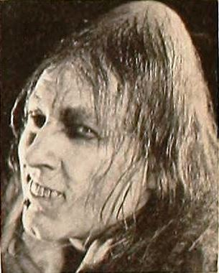
“"I have been wanting to speak to you, Jekyll," began the latter. "You know that will of yours?"
A close observer might have gathered that the topic was distasteful; b ut the doctor carried it off gaily.” (Chapter 3)
In contrast to Hyde, Jekyll is very relaxed and in good spirits in terms of talking about awkward topics.

“And then all of a sudden he broke out in a great flame of anger, stamping with his foot, brandishing the cane, and carrying on (as the maid described it) like a madman. The old gentleman took a step back, with the air of one very much surprised and a trifle hurt; and at that Mr. Hyde broke out of all bounds and clubbed him to the earth. And next moment, with ape-like fury, he was trampling his victim under foot and hailing down a storm of blows, under which the bones were audibly shattered and the body jumped upon the roadway.” (Chapter 4)
Hyde’s violence towards Sir Danvers Carew is sickening in its brutality. He is ruthless.

“The most racking pangs succeeded: a grinding in the bones, deadly nausea, and a horror of the spirit that cannot be exceeded at the hour of birth or death.” (Chapter 10)
Jekyll explains that the actual transformation into Hyde was painful at first.
“Instantly the spirit of hell awoke in me and raged. With a transport of glee, I mauled the unresisting body, tasting delight from every blow; and it was not till weariness had begun to succeed, that I was suddenly, in the top fit of my delirium, struck through the heart by a cold thrill of terror. A mist dispersed; I saw my life to be forfeit; and fled from the scene of these excesses, at once glorying and trembling, my lust of evil gratified and stimulated, my love of life screwed to the topmost peg.” (Chapter 10)
Jekyll explains that Hyde loved violent acts – does this mean Dr Jekyll did too?

“Once a woman spoke to him, offering, I think, a box of lights. He smote her in the face, and she fled.” (Chapter 10)
Even when people are polite and kind to Hyde, he cannot resist violence towards them.

Revision Activity 4: Characters
Mr Utterson
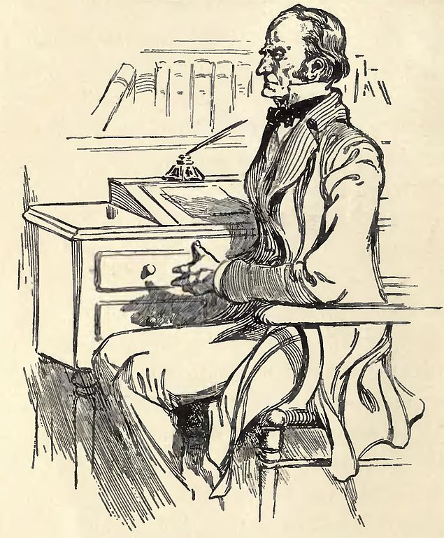
- The narrator tells the story from the perspective of Utterson for the majority of the novella
- Utterson is a lawyer and very ‘repressed’: he rarely drinks, has little in the way of ‘fun’ and is sometimes jealous of people who have transgressed or committed wrongs.
- Rather than judge those who do wrong, he feels sorry for them or tries to help them.
- He is highly respected as a person in Victorian society because of his excellent reputation.
- He is also friends with Dr Lanyon and Enfield.
- Utterson is Dr Jekyll’s lawyer and so deals with his will, but also considers him his friend.
- He is initially fascinated by Hyde but comes to be disguste d by his violence.
- Utterson tries to warn Dr Jekyll away from Mr Hyde.
- Utterson guides us through the mystery before it is eventually solved.
Dr Lanyon
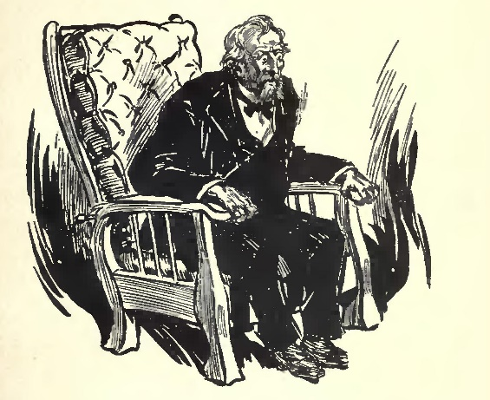
- Previously he had been close friends with Dr Jekyll, but distanced himself from the scientist after learning of Jekyll’s bizarre – and what he sees as unchristian and blasphemous – experiments.
- Lanyon, like Utterson, is highly respected in society.
- However, Lanyon later becomes very ill and refuses to speak to anyone about Jekyll.
- He later dies and leaves Utterson with a letter which he says must not be read until Jekyll either disappears or dies himself.
- The letter reveals Lanyon witnessed Jekyll’s transformation into Hyde and reveals Hyde’s true identity.

Dr Henry Jekyll
- Well respected in Victorian society, Jekyll is a doctor of medicine with many friends.
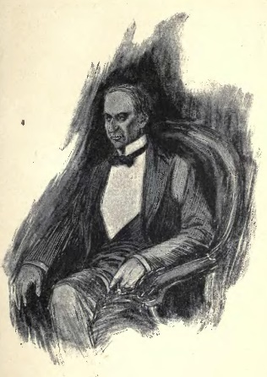
- Utterson learns Hyde is living in Jekyll’s house and starts to question Jekyll about him. Jekyll tells him not to worry.
- When Hyde kills Sir Danvers Carew, Jekyll becomes reclusive and isolates himself away from his friends.
- After the police say Hyde is missing, Jekyll becomes happier once more.
- Jekyll later disappears and so Utterson reads t he confession and new will that Jekyll left him.
- It is revealed that Jekyll was Hyde and we begin to understand Jekyll’s inner most thoughts.
- Jekyll’s confession reveals that he was trying to remove the evil from himself to create a purely good being, but instead transformed himself into a completely evil creature that he named Mr Hyde.
Mr Edward Hyde
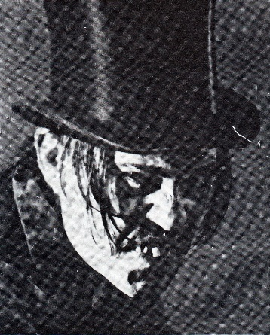
- A small, heavily disfigured and deformed man, who is described as ‘ape like’ but also a ‘juggernaut’.
- He hurts a young girl and does not seem to care – something that Enfield witnessed.
- He is violent towards Utterson and later attacks Sir Danvers Carew – a highly respected gentleman.
- Hyde is described as not being human and unnatural, as if he is not quite evolved. People seem to feel a natural disgust for Hyde.
- Hyde’s crimes take pla ce at night.
- Hyde’s body is discovered on the floor of Jekyll’s laboratory.
- Lanyon’s letter and Jekyll’s confession reveal Hyde was Jekyll.
Minor characters
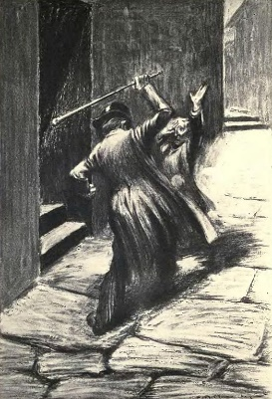
- Sir Danvers Carew: A very respected and prominent member of Victorian society who is brutally murdered by Hyde launching a police investigation.
- Enfield: Utterson’s cousin, he only appears a couple of times in the novel but is used to introduce the idea of Hyde to Utterson.
- Mr Guest: A clerk who works for Utterson and discovers the similarity between Jekyll and Hyde’s handwriting.
- Richard Poole: Jekyll’s butler, he grows suspicious of Hyde and of Jekyll’s behaviour and asks for Utterson’s assistance. They discover Hyde’s dead body in Jekyll’s laboratory wearing his clothes.

- Challenge: Read through the notes on each of the characters and highlight important information.
- Extra Challenge: Create a ‘character map’ to explain how all the characters link together in the novella.
- Mega Challenge: Why did Stevenson choose Utterson as his main protagonist? Why leave Jekyll’s confession until the end of the novella?
Revision Activity 5: Historical context (AO3)
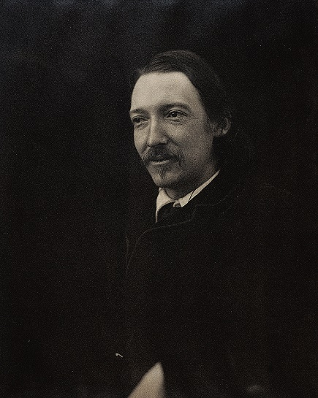
Part of the mark scheme for the exam questions asks you to be able to explain th e novella based on the time it was written in (the Victorian period). You will find some key contextual information below:
Robert Louis Stevenson was born in Edinburgh in Scotland in 1850 and came from a family of scientists, engineers, religious figures and even a professor of philosophy. Because of this, it is possible to explain why Stevenson was so interested in the relationship between science and nature in his novella.
As a child, Stevenson was often very ill – including suffering from lung problems – who would often distract himself from his illness by reading about travel and adventures. This later inspired him to write ‘Treasure Island’ and he would travel the world before dying in the Samoan Islands in the South Pacific in 1894 at the relatively young age of 44.
Stevenson’s illness meant he would often suffer from nightmares and this influenced his writing in Jekyll and Hyde. Think about how Hyde generally only appears at night and how Utterson has a dream involving both Jekyll and Hyde. The darkness of the city at night provided the perfect backdrop for an evil and notorious character like Hyde to commit his crimes.
In 1859 Charles Darwin published his famous On the Origin of Species, which explained Darwin’s Theory of Evolution. This introduced the idea of animals changing in response to their environments through mutations at birth, or evolving. This theory questioned accepted Christian beliefs that the world was created in seven days.
Many people within society also struggled to accept the idea that humans could have evolved from other animals such as chimpanzees. It was this idea of evolution that again inspired Stevenson to write Jekyll and Hyde.
Science and religion are two very important themes in the novella, and at this time many felt science and religion were at odds with each other – to believe in one meant you could not believe in the other. Characters like Dr Lanyon and Mr Utterson have scientific minds but seem to be very religious in their beliefs as well. Jekyll, by experimenting on himself, seems to ‘play God’ and as such loses his life. Was this Stevenson suggesting only God should have this power?
The novella is packed full with ideas of duality: everyone has two sides to them (the good and the evil); nature is in conflict with the supernatural; science is in conflict with religion.
It was published in 1886 and only two years later the Jack the Ripper murders were causing chaos and panic in London. A series of violent attacks took place on prostitutes across the city with five being killed by the mysterious Ripper – whose true identity was never discovered. Rumours were spreading that the serial killer could be middle or upper class, challenging the idea that those high up in society were naturally good and morally strong.
- Challenge: Read through this contextual information. How has it changed your understanding of the novella?
- Extra Challenge: Why was this time such a challenging one for the Victorians? What beliefs were being questioned? How does the novel show these ideas?
- Mega Challenge: Complete your own independent research and about Stevenson and what influenced him to write the novella. Find out about his home city of Edinburgh and how this affected his writing.
Revision Activity 5: Exam-style question
As well as answering the Shakespeare question in Section A, you will need to answer ONE question on The Strange Case of Dr Jekyll and Mr Hyde.
In the question you will be given a short extract from somewhere in the novella and you will be asked to explore a key character or theme in this part of the text as well as the rest of the novella.
Here is an example question:
Read the following extract from Chapter 2 and then answer the question
that follows.

In this extract Mr Utterson has just met Mr Hyde for the first time.

‘We have common friends,’ said Mr Utterson.
‘Common friends!’ echoed Mr Hyde, a little hoarsely.
‘Who are they?’
‘Jekyll, for instance,’ said the lawyer.
‘He never told you,’ cried Mr Hyde, with a flush of anger. ‘I did not think you would have lied.’
‘Come,’ said Mr Utterson, ‘that is not fitting language.’
The other snarled aloud into a savage laugh; and the next moment, with
extraordinary quickness, he had unlocked the door and disappeared into the house.

The lawyer stood awhile when Mr Hyde had left him, the picture of disquietude.

Then he began slowly to mount the street, pausing every step or
two and putting his hand to his brow like a man in mental perplexity.

The problem he was thus debating as he walked was one of a class that is rarely solved.

Mr Hyde was pale and dwarfish; he gave an impression of deformity
without any nameable malformation, he had a displeasing smile, he had
borne himself to the lawyer with a sort of murderous mixture of timidity and boldness, and he spoke with a husky whispering and somewhat broken voice, – all these were points against him; but not all of these together could explain the hitherto unknown disgust, loathing and fear with which Mr Utterson regarded him.

‘There must be something else,’ said the perplexed gentleman.
‘There is something more, if I could find a name for it. God bless me, the man seems hardly human! Something troglodytic, shall we say? Or can it be the old story of Dr Fell? Or is it the mere radiance of a foul soul that
thus transpires through, and transfigures, its clay continent? The last, I think; for, O my poor old Harry Jekyll, if ever I read Satan’s signature upon a face, it is on that of your new friend!’

Starting with this extract, how does Stevenson present Mr Hyde as a frightening outsider?

Write about:
• how Stevenson presents Mr Hyde in this extract
• how Stevenson presents Mr Hyde as a frightening outsider in the novel as a whole.

[30 marks]

- Challenge: Make notes on how Hyde is presented as frightening to the reader and also as an outsider in this extract.
- Extra Challenge: Make notes on how Hyde is presented as frightening and as an outsider in the rest of the text.
- Mega Challenge: Write the start of your essay answer – addressing both bullet points.

Notes:
__________________________________________________________________________________________________________________________________________________________________________________________________________________________________________________________________________________________________________________________________________________________________________________________________________________________________________________________________________________________________________________________________________________________________________________________________________________________________________________________________________________________________________________________________________________________________________________________________________________________________________________________________________________________________________________________________________________________________________________________________________________________________________________________________________________________________________________________________________________________________________________________________________________________________________________________________________________________________________________________________________________________________________________________________________________________________________________________________________________________________________________________________________________________________________________________________________________________________________________________________________________________________________________________________________________________________________________________________________________________________________________________________________________________________________________________________________________________________________________________________________________________________________________________________________________________________________________________________________________________________________________________________________________________________________________________________________________________________________________________________________________________________________________________________________________________________________________________________________________________________________________________________________________________________________________________________________________________________________________________________________________________________________________________________________________________________________________________________________________________________________________________________________________________________________________________________________________________________________________________________________________________________________________________________________________________________________________________________________________________________________________________________________________________________________________________________________________________________________________________________________________________________________________________________________________________________________________________________________________________________________________________________________________________________________________________________________________________________________________________________________________________________________________________________________________________________________________________________________________________________________
________________________________________________________________________________________________________________________________________________________________________________________________________________________________________________________________________________________________________________________________________________________________________________________________________________________________________________________________________________________________________________________________________________________________________________________________________________________________________________________________________________________________________________________________________________________________________________________________________________________________________________________________________________________________________________________________________________________________________________________________________________________________________________________________________________________________________________________________________________________________________________________________________________________________________________________________________________________________________________________________________________________________________________________________________________________________________________________________________________________________________________________________________________________________________________________________________________________________________________________________________________________________________________________________________________________________________________________________________________________________________________________________________________________________________________________________________________________________________________________________________________________________________________________________________________________________________________________________________________________________________________________________________________________________________________________________________________________________________________________________________________________________________________________________________________________________________________________________________________________________________________________________________________________________________________________________________________________________________________________________________________________________________________________________________________________________________________________________________________________________________________________________________________________________________________________________________________________________________________________________________________________________________________________________________________________________________________________________________________________________________________________________________________________________________________________________________________________________________________________________________________________________________________________________________________________________________________________________________________________________________________________________________________________________________________________________________________________________________________________________________________________________________________________________________________________________________________________________________________________________________________________________________________________________________________________________________________________________________________________________________________________________________________________________________________________________________________________________________________________________________________________________________________________________________________________________________________________________________________________________________________________________________________________________________________________________________________________________________________________________________________________________________________________________________________________________________________________________________________________________________________________________________________________________________________________________________________________________________________________________________________________________________________________________________________________________________________________________________________________________________________________________________________________________________________________________________________________________________________________________________________________________________________________________________________________________________________________________________________________________________________________________________________________________________________________________________________________________________________________________________________________________________________________________________________________________________________________________________________________________________________________________________________________________________________________________________________________________________________________________________________________________________________________________________________________________________________________________________________________________________________________________________________________________________________________________________________________________________________________________________________________________________________________________________________________________________________________________________________________________________________________________________________________________________________________________________________________________________________________________________________________________________________________________________________________________________________________________________________________________________________________________________________________________________________________________________________________________________________________________________________________________________________________________________________________________________________________________________________________________________________________________________________________________________________________________________________________________________________________________________________________________________________________________________________________________________________________________________________________________________________________________________________________________________________________________________________________________________________________________________________________________________________________________________________________________________________________________________________________________________________________________________________________________________________________________________________________________________________________________________________________________________________________________________________________________________________________________________________________________________________________________________________________________________________________________________________________________________________________________________________________________________________________________________________________________________________________________________________________________________________________________________________________________________________________________________________________________________________________________________________________________________________________________________________________________________________________________________________________________________________________________________________________________________________________________________________________________________________________________________________________________________________________________________________________________________________________________________________________________________________________________________________________________________________________________________________________________________________________________________________________________________________________________________________________________________________________________________________________________________________________________________________________________________________________________________________________________________________________________________________________________________________________________________________________________________________________________________________________________________________________________________________________________________________________________________________________________________________________________________________________________________________________________________________________________________________________________________________________________________________________________________________________________________________________________________________________________________________________________________________________________________________________________________________________________________________________________________________________________________________________________________________________________________________________________________________________________________________________________________________________________________________________________________________________________________________________________________________________________________________________________________________________________________________________________________________________________________________________________________________________________________________________________________________________________________________________________________________________________________________________________________________________________________________________________________________________________________________________________________________________________________________________________________________________________________________________________________________________________________________________________________________________________________________________________________________________________________________________________________________________________________________________________________________________________________________________________________________________________________________________________________________________________________________________________________________________________________________________________________________________________________________________________________________________________________________________________________________________________________________________________________________________________________________________________________________________________________________________________________________________________________________________________________________________________________________________________________________________________________________________________________________________________________________________________________________________________________________________________________________________________________________________________________________________________________________________________________________________________________________________________________________________________________________________________________________________________________________________________________________________________________________________________________________________________________________________________________________________________________________________________________________________________________________________________________________________________________________________________________________________________________________________________________________________________________________________________________________________________________________________________________________________________________________________________________________________________________________________________________________________________________________________________________________________________________________________________________________________________________________________________________________________________________________________________________________________________________________________________________________________________________________________________________________________________________________________________________________________________________________________________________________________________________________________________________________________________________________________________________________________________________________________________________________________________________________________________________________________________________________________________________________________________________________________________________________________________________________________________________________________________________________________________________________________________________________________________________________________________________________________________________________________________________________________________________________________________________________________________________________________________________________________________________________________________________________________________________________________________________________________________________________________________________________________________________________________________________________________________________________________________________________________________________________________________________________________________________________________________________________________________________________________________________________________________________________________________________________________________________________________________________________________________________________________________________________________________________________________________________________________________________________________________________________________________________________________________________________________________________________________________________________________________________________________________________________________________________________________________________________________________________________________________________________________________________________________________________________________________________________________________________________________________________________________________________________________________________________________________________________________________________________________________________________________________________________________________________________________________________________________________________________________________________________________________________________________________________________________________________________________________________________________________________________________________________________________________________________________________________________________________________________________________________________________________________________________________________________________________________________________________________________________________________________________________________________________________________________________________________________________________________________________________________________________________________________________________________________________________________________________________________________________________________________________________________________________________________________________________________________________________________________________________________________________________________________________________________________________________________________________________________________________________________________________________________________________________________________________________________________________________________________________________________________________________________________________________________________________________________________________________________________________________________________________________________________________________________________________________________________________________________________________________________________________________________________________________________________________________________________________________________________________________________________________________________________________________________________________________________________________________________________________________________________________________________________________________________________________________________________________________________________________________________________________________________________________________________________________________________________________________________________________________________________________________________________________________________________________________________________________________________________________________________________________________________________________________________________________________________________________________________________________________________________________________________________________________________________________________________________________________________________________________________________________________________________________________________________________________________________________________________________________________________________________________________________________________________________________________________________________________________________________________________________________________________________________________________________________________________________________________________________________________________________________________________________________________________________________________________________________________________________________________________________________________________________________________________________________________________________________________________________________________________________________________________________________________________________________________________________________________________________________________________________________________________________________________________________________________
____________________________________________________________________________________________________________________________________________________________________________________________________________________________________________________________________________________________________________________________________________________________________________________________________________________________________________________________________________________________________________________________________________________________________________________________________________________________________________________________________________________________________________________________________________________________________________________________________________________________________________________________________________________________________________________________________________________________________________________________________________________________________________________________________________________________________________________________________________________________________________________________________________________________________________________________________________________________________________________________________________________________________________________________________________________________________________________________________________________________________________________________________________________________________________________________________________________________________________________________________________________________________________________________________________________________________________________________________________________________________________________________________________________________________________________________________________________________________________________________________________________________________________________________________________________________________________________________________________________________________________________________________________________________________________________________________________________________________________________________________________________________________________________________________________________________________________________________________________________________________________________________________________________________

