Macbeth
Wider Reading Booklet

An introduction to Shakespearean Tragedy
An Introduction to Macbeth
The Witches in Macbeth
Character analysis: Lady Macbeth
Conjuring darkness in Macbeth
Lady Macbeth’s ‘Hell Broth’
Malcolm in Macbeth

All extracts takes from the British Library website
https://www.bl.uk/works/macbeth

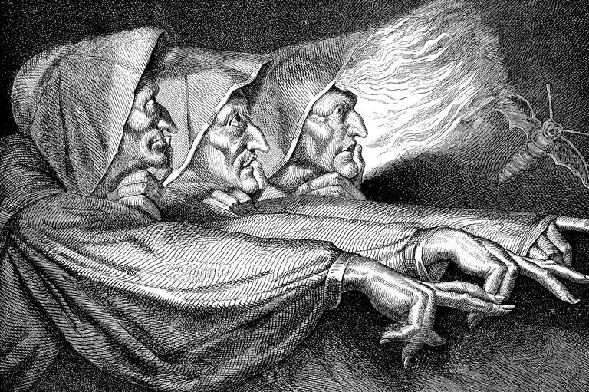
Extracts from An introduction to Shakespearean Tragedy
Source: https://www.bl.uk/shakespeare/articles/an-introduction-to-shakespearean-tragedy

Once one understands that, it’s much easier to see what the other tragedies have in common with the tragedies of love, and what’s characteristically Shakespearean about them too. Shakespeare’s tragic protagonists, the fictional universes they inhabit, and the tragic fates that await them are amazingly diverse. But every one of his tragic protagonists is doomed by having been cast in the wrong role in the wrong place in the wrong time. Every one of them becomes a stranger in a world where they had once felt at home, and a stranger to the person that they used to be or thought they were. And in the process, every one of them reveals the potential they possess to be another kind of person in another kind of world, which they will tragically never live to see.

Take, for example, Hamlet: cruelly miscast as a 16th-century prince, bewildered by his inability to sweep to the revenge he has sworn to take, and so alienated from a time he perceives to be ‘out of joint’ that ‘all the uses of this world’, including sovereignty itself and everything it entails, have become ‘weary, stale, flat, and unprofitable’ to him. Or King Lear: forced to feel what the ‘Poor naked wretches’ of his kingdom feel; to see the vulnerable human being – ‘unaccommodated man’ – beneath a mad beggar’s rags and his royal robes; and to recognise the systemic injustice and inherent inhumanity of the regime over which he had presided so thoughtlessly for so long. Or Macbeth: the noble warlord who murders a fellow human being for his crown, is tortured by guilt as a consequence, and winds up butchering his way to oblivion, in spite of being, as his own wife attests, ‘too full o’ th’ milk of human kindness’.

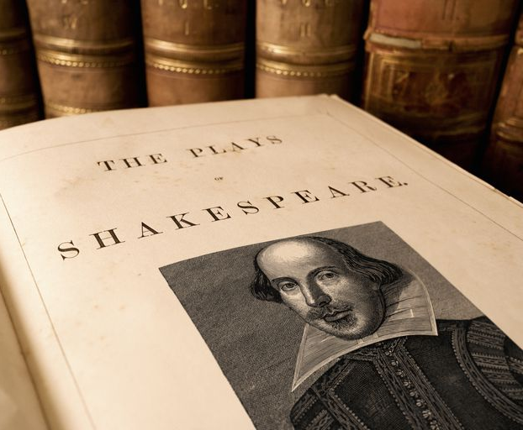
Extracts from An Introduction to Macbeth
Source: https://www.bl.uk/works/macbeth

The tragedy Macbeth is set in medieval Scotland. Three witches in a storm plan to meet Macbeth, a warrior and Thane, after the current battle, an uprising against King Duncan. As the victorious Macbeth and Banquo cross a heath, the witches appear to them. They address Macbeth first as Thane of Glamis (his current title), then as Thane of Cawdor (the title of one of the rebels) and finally as King. They also tell Banquo that his descendants shall be kings. The witches vanish and noblemen approach Macbeth to tell him that Duncan has named him the new Thane of Cawdor. Macbeth now understands the witches’ pronouncement as a prophecy. He writes to tell his wife what has happened. Lady Macbeth muses on ambition and invokes dark spirits to fill her with cruelty in preparation for helping Macbeth take the throne.

Duncan and his retinue come to Macbeth’s castle. The Macbeths plot to kill him. Macbeth has second thoughts, but is spurred on by his wife and commits the murder. He also kills Duncan’s guards and Lady Macbeth plants the bloody daggers on them. A knocking at the gate rouses the household and Duncan’s corpse is discovered. Macbeth claims to have killed the guards in righteous fury. Duncan’s sons, Malcolm and Donalbain, flee in fear of their lives. Macbeth takes the crown.

Macbeth remembers that Banquo witnessed the witches’ prophecy and hires murderers to kill him and his son, Fleance; Fleance escapes. Macbeth is haunted by Banquo’s ghost at a feast. Macbeth seeks further counsel from the witches, who produce visions that tell Macbeth to be wary of Macduff, but that he cannot be harmed by any man born of woman, nor will he be vanquished until Birnam Wood comes to Dunsinane Hill. A fourth vision shows that Banquo’s descendants will be kings.

The play descends further into darkness as Macbeth has Macduff’s family slaughtered and learns that Lady Macbeth has gone mad with guilt. She dies, probably by suicide. Malcolm, Macduff and the other nobles take arms against Macbeth. The advancing army camouflage themselves by cutting boughs from Birnam Wood, creating the impression that the wood is coming to the hill. Macduff and Macbeth fight; Macduff reveals that he was not ‘born’ but rather cut from his mother’s womb. He kills Macbeth and Malcolm is crowned King.

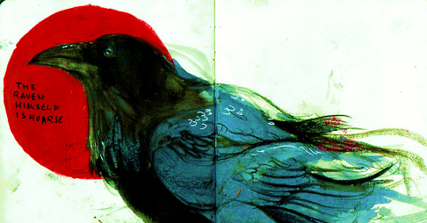
Extracts from The Witches in Macbeth
Source: https://www.bl.uk/shakespeare/articles/character-analysis-the-witches-in-macbeth

Shakespeare wrote Macbeth at a time when interest in witchcraft bordered on hysteria. Witches were blamed for causing illness, death and disaster, and were thought to punish their enemies by giving them nightmares, making their crops fail and their animals sicken. Witches were thought to allow the Devil to suckle from them in the form of an animal, such as ‘Graymalkin’ and ‘Paddock’, the grey cat and the toad mentioned by the Witches in Act 1, Scene 1.

King James VI of Scotland was deeply concerned about the threat posed by witches. He believed that a group of witches had tried to kill him by drowning him while he was at sea (a curse echoed here by the First Witch). During his reign thousands of people in Scotland were put on trial for witchcraft. In 1604, under his rule as King of England and Wales, witchcraft was made a capital offence, meaning that anyone who was found guilty of being a witch could be executed. When Shakespeare wrote Macbeth in 1606, then, he knew that his audience would have felt a mixture of fear and fascination for the three ‘weird sisters’, their imaginations captivated by the mysterious meeting on the desolate heath with which the play begins.

Throughout the play, the language used by the Witches helps to mark them out as mysterious and other-worldly. They speak in verse, but it is a form of verse that is very different from that which is used by most of Shakespeare’s characters. Many of the lines in this passage are in rhyming couplets, in contrast to the unrhymed verse used elsewhere in the play.

In Act 1, Scene 2, Macbeth is presented as a loyal warrior, a hero who fights valiantly on the battlefield to defend his country against invasion and treachery. Yet the association between Macbeth and the Witches introduces a different side to his character. When Macbeth and Banquo meet the Witches, their reactions give us an important insight into their personalities. Banquo is unafraid, but Macbeth [is] so mystified by their greeting that he is rendered speechless. Once he has regained his composure, he challenges the Witches to tell him more.

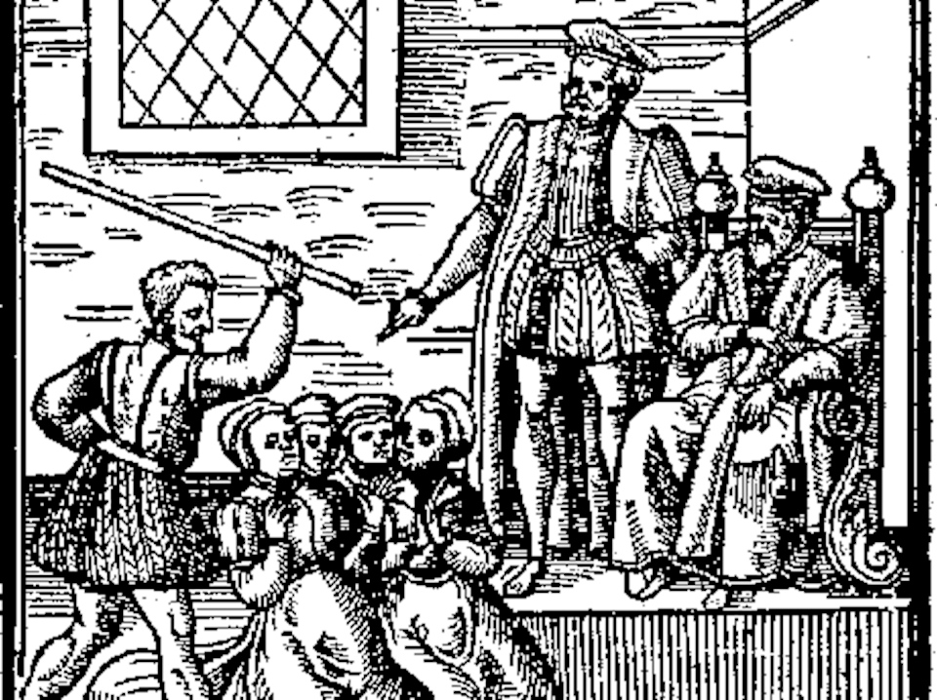
Extracts from Character analysis: Lady Macbeth
Source: https://www.bl.uk/shakespeare/articles/character-analysis-lady-macbeth

Act 1, Scene 5 of Macbeth is set in Macbeth’s castle in Inverness. It forms part of the audience’s first encountering of Lady Macbeth. Lady Macbeth has just read Macbeth’s letter, which outlines the weird sisters’ prophecies. She proceeds to express to herself her concern that Macbeth does not possess the steeliness or desire to use underhand means to acquire the glittering titles the witches have said lay before him.

In this scene, Lady Macbeth’s characterisation is used to continue the play’s steady ratcheting up of tension. The suspense of this passage is enhanced by the fact that Lady Macbeth’s soliloquy after the messenger has left is uttered in a stolen moment of stillness before action and fretful dialogue commences. It is a fleeting opportunity for her to consider her own feelings and responses to the unfolding events before Macbeth enters with weaknesses that will inevitably require her ‘tending’.

The soliloquy’s opening image – a croaking raven – is a telling one. The bird not only has associations of ill omens but was also renowned for eating the decayed flesh of fallen soldiers on battlefields, closely linking to the idea of the Macbeths – and Lady Macbeth in particular – being a sinister, parasitical couple feeding on the lives of those more powerful and benevolent than themselves.

[Lady Macbeth] does not want to remain in a sexless, physically diminished state. She also wants to be reconstituted and refigured as a being hard and armoured like her warrior husband; as a monstrous being with unnaturally thickened blood and breasts that produce deadly poisonous ‘gall’.

The most familiar, recognisable reading of Lady Macbeth’s role in the play is that she is the puppet master who pulls – often mercilessly yanks – at Macbeth’s strings. Several aspects of her portrayal in Act 1, Scene 5 add to this view. When Macbeth enters, not only does she shape and direct his behaviour, she also speaks significantly more than he does. Macbeth’s utterances are concise and practical, hers expansive, detailed and richly embroidered with imagery, reflecting the elaborate workings of a mind masterminding a dastardly plan. The perception of Lady Macbeth as the powerful, motivating force behind the couple’s scheme is of course sharpened in Act 1, Scene 7 when, using terrifying images of infanticide and her ‘undaunted mettle’, she taunts Macbeth for his lack of masculine resolve and reignites his passion to pursue power at any cost.

Extracts from Conjuring darkness in Macbeth
Source: https://www.bl.uk/shakespeare/articles/conjuring-darkness-in-macbeth

Key scenes of the play are set at night, and even in many of the daytime scenes characters are aware of the fading of the light. The Witches who open the play agree that they will meet Macbeth ‘ere the set of sun’; Duncan arrives at Macbeth’s castle at evening; the First Murderer, instructed by Macbeth to kill Banquo and Fleance, notes how ‘The west yet glimmers with some streaks of day’. We often feel darkness coming, especially because both Macbeth and Lady Macbeth seem to invoke and invite it. They need darkness to do their worst.

On a stage crowded with Duncan and his thanes, Macbeth speaks in one of his asides that allow us to hear his unspoken thoughts – ‘Stars, hide your fires, / Let not light see my black and deep desires’. This is the first reference to darkness in the play. He has just found out that he has become Thane of Cawdor, as prophesied by the Witches, and that Duncan is to visit his castle.

Darkness may seem to become Macbeth’s element, but his wife, once the prime mover of their plots, comes to dread it. Watching her sleepwalking, her Gentlewoman tells the Doctor that ‘she has light by her continually, ’tis her command’. Once she called ‘Come, thick night, / And pall thee in the dunnest smoke of hell’; now she feels and fears ‘Hell is murky’. In her final scene before her death, Shakespeare shows how the horror of her deeds has possessed her, and does so by dramatising the most elemental and childlike of fears: fear of the dark.

Extracts from Lady Macbeth’s ‘Hell Broth’
Source: https://www.bl.uk/shakespeare/articles/unsex-me-here-lady-macbeths-hell-broth

Throughout most of literary history, Lady Macbeth – the scheming spouse who plots the villainy at the centre of Shakespeare’s devastating ‘Scottish play’ – has been seen as a figure of ‘almost peerless malevolence’. Monstrous and murderous, she was based on a woman described in Holinshed’s Chronicles as ‘burning in unquenchable desire to beare the name of a queene’.

From a more recent perspective, however, Lady Macbeth has come to be seen not primarily as a fiendish avatar of evil but as an incarnation of gender trouble whose efforts to implement her dreams of power question the sexual hierarchy into which she has been born. Almost her first words in the play, after she receives her husband’s letter reporting his encounter with the witches, dramatise the inversion of gender roles that marks her marriage.

Lady Macbeth’s passion to transcend her role as a woman becomes even more explicit in her famous call to the diabolical ‘Spirits’ to ‘unsex’ her […] Lady Macbeth is now no longer a conventional ‘lady’: because she has refused to behave as dutifully as her society suggests she should

By the end of the play, the couple have been restored to their ‘proper’ gender roles. Macbeth gains in murderous masculinity, ordering killing after killing like a gangland boss, including the deaths of the dutifully domesticated Lady Macduff and the ‘pretty ones’ who are her children, while Lady Macbeth lapses back into the feminine helplessness she had earlier rejected. Her loss of control is most theatrically manifested in her guilt-ridden sleep-walking scene. Here the sleep, whose murder she had commanded, overwhelms her, forcing her to confess her sins while failing to ‘knit up the ravell’d sleeve of care’. And though Macbeth too had wished to purify himself of crime, grandiosely fearing that he could not be cleansed by ‘all great Neptune’s ocean’, his sleep-walking lady, enacting an obsessive-compulsive ritual of hand-washing, whimpers that ‘all the perfumes of Arabia will not sweeten this little hand’. Madness, curiously, forces her back into the stereotypical femininity that her transgressive yearning for imperial power had repudiated.

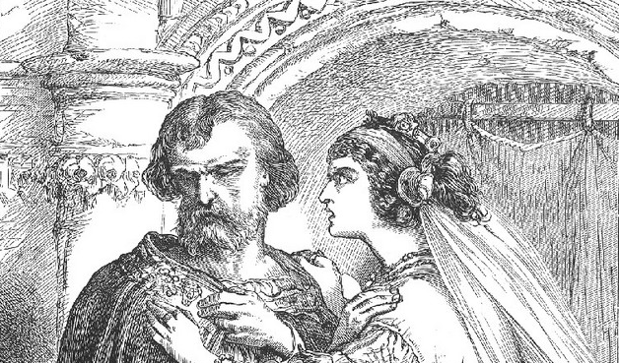
Extracts from Malcolm in Macbeth
Source: https://www.bl.uk/shakespeare/articles/character-analysis-malcolm-in-macbeth

The final scene of Shakespeare’s Macbeth signals balance after excess, kingship after tyranny, and calm after conflict. The noble Macduff has defeated Macbeth in single man-to-man combat, as an act of vengeance for the slaughter of his family. Macduff then presents the young Malcolm with Macbeth’s ‘cursed head’ as a trophy of victory. This marks the exchange of power from Macbeth as false ‘usurper’ to Malcolm as the legitimate ‘King’. Malcolm rewards his loyal thanes by making them Scotland’s first earls; he calls his people home from exile, and invites them to see him crowned. The broken circle seems mended as Malcolm – the son of the murdered King Duncan – is restored to the Scottish throne.

Malcolm’s words seem deliberately measured and precise after Macbeth’s excesses. He uses financial language, promising not to ‘spend a large expense of time’ before he reckons up the love of his thanes, and repays what he owes. Similarly Duncan expresses his gratitude in terms of debt and ‘payment’. When Malcolm says he will do what’s needed in ‘measure, time, and place’, the commas force the actor to pause, slow down and fully savour the moment, letting the audience breathe a collective sigh of relief. As so often in Shakespeare, the last lines are rhyming couplets, reinforcing the sense of balance: ‘So thanks to all at once, and to each one / Whom we invite to see us crown’d at Scone’.

Yet despite his composed manner, Malcolm’s description of Macbeth and Lady Macbeth is unflinchingly brutal. He bluntly redefines them as a ‘dead butcher, and his fiend-like queen’, reminding us of how far they’ve sunk from the ‘noble’ couple they seemed. His language seems to deprive them of their complex humanity. It compares Lady Macbeth to the witches or ‘juggling fiends’ and reduces Macbeth to a bloody, emotionless killer. In doing so, Malcolm makes us confront the full horror of their actions, but he also increases the pathos of their tragic fall from greatness.

The scene is sometimes performed with a loud fanfare and cheering crowds, creating a stirring image of new hope for Scotland. But many critics and directors see the end of Macbeth as unresolved and unsettling. Malcolm might attempt to present an air of finality, but we often have a lingering sense of the tragic loss of Macbeth, or the haunting power of the witches.

